**Vacation Bible School**

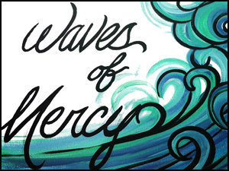

Dates:  **AUGUST 8-11**

Time: **5:00 - 7:00 PM**

Location: **HENES PARK   
 (Pavilion #3)**

100 Henes Park Drive, Menominee

Kids from preschool through 6th grade are invited  
to play games, create arts and crafts, sing songs, and hear Bible stories that connect water with God’s word.

Sack lunches will be available free of charge to campers and their families at 5:00 pm and small groups will rotate between stations throughout the evening.  
  
Pre-registration is encouraged. Registration forms are available at Bethel Lutheran in Menominee, Zion Lutheran in Marinette, St. James Lutheran in Marinette and Peace United in Marinette or email sehle@uwalumni.com.

We hope you can join us!!!